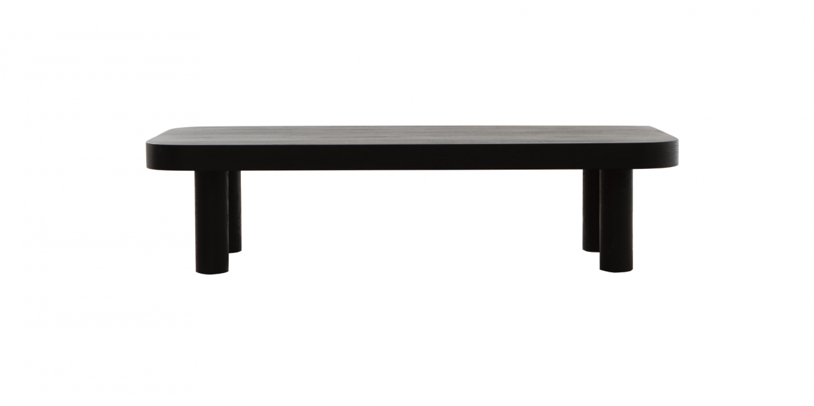

$259,97

Inspired by volumetric designs, the Bold table collection is crafted with a thick tabletop, large-pillar legs turned from solid wood, which will be a unique highlight that captivates you.

